 | 
Laboratory 4: Integration of Sensors with ESP32 | School of Applied Digital Technology
Name:  Name: | ID:  ID: | Section:  Section:
Date: | Due date:

Objectives
- Connect a Servo Motor and Buzzer to the ESP32 board.
- Configure ESPHome to control these components.
- Monitor and control the devices through Home Assistant.
Experiment 1: Integration of Sensors with ESP32
Equipment:
 | Quantity
ESP32 | 1
Motion Sensor Detector Module HC-SR501 | 1
LDR Photosensitive Sensor Module Light Sensor | 1

- Wiring the Sensors to the ESP Board

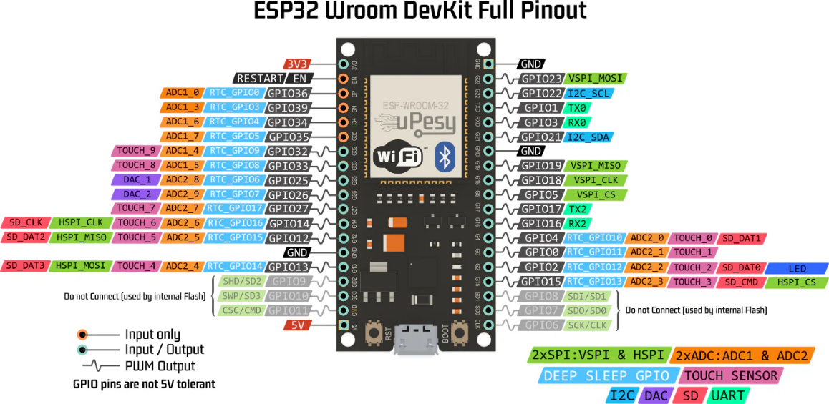

- Motion Sensor Detector Module HC-SR501
  - VCC → 3V
  - GND → GND
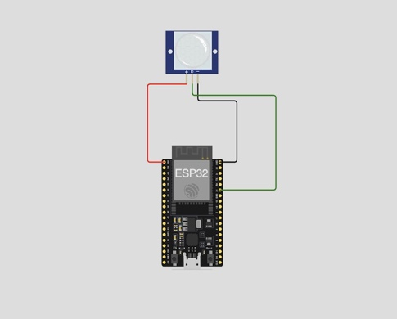
  - OUT → GPIO14

LDR Photosensitive Sensor Module Light Sensor
  - VCC → 3V
  - GND → GND
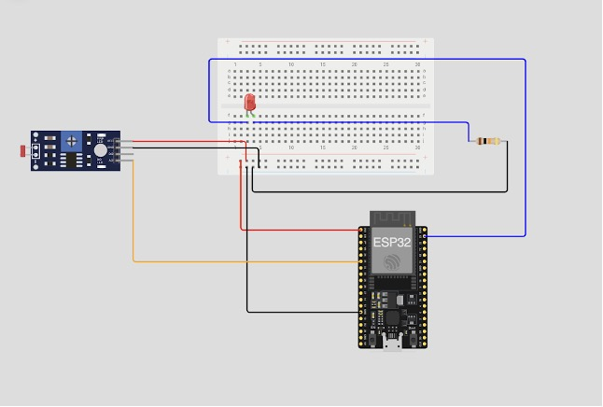
  - OUT → GPIO14

2. Open ESPHome and Select the Device
- Go to the ESPHome Dashboard
- Select your device (e.g., sensor)
- Click EDIT to modify the YAML configuration

3. Add Code for the Sensors in the YAML File
Add the following to your configuration file:
- Motion Sensor Detector Module HC-SR501
# PIR Motion Sensor
binary_sensor:
- platform: gpio
pin:
number: GPIO14
mode: INPUT
name: "Living Room Motion"
device_class: motion

LDR Photosensitive Sensor Module Light Sensor
# ----------------------------
# Analog LDR (AO)
# ----------------------------
sensor:
- platform: adc
pin: GPIO35
name: "Living Room Light (Analog)"
update_interval: 10s
attenuation: 11db
filters:
- multiply: 3.3

# ----------------------------
# Digital LDR (DO)
# ----------------------------
binary_sensor:
- platform: gpio
pin: GPIO26
name: "Bright Light Detected (Digital)"
device_class: light
filters:
- delayed_on: 100ms
- delayed_off: 100ms

4. Save and Install the Firmware
- Click SAVE
- Click INSTALL
- Choose Wirelessly or USB depending on your setup
- Wait for the upload to complete and let the device reboot
5. View Sensor Data in Home Assistant
- Go to your Home Assistant Overview Dashboard
- You should now see sensor readings such as:
- Servo Motor (PWM)
- Buzzer
Take 1: Design an LED control system using a light sensor (LDR) to automatically turn ON the LED when it is dark and OFF when it is bright.
Requirements:
1. Use an ESP32 board and an LDR sensor (Analog + Digital).
2. Connect an LED to indicate light/dark condition.
3. Read LDR Analog values every 1 second.
4. Combine the Analog/Digital sensor reading and LED control code into a single ESPHome YAML file.
5. Implement automation so the LED operates according to the following conditions:
• LDR Analog < 2.0V → LED turns ON (dark)
• LDR Analog ≥ 2.0V → LED turns OFF (bright)

Continued on the next page.
CODE:

----- Have a good day -----
ANSWER:
# LED Output
output:
- platform: gpio
pin: GPIO13
id: led_output

# Analog LDR
sensor:
- platform: adc
pin: GPIO34
name: "LDR Analog"
id: ldr_analog
update_interval: 1s
attenuation: 11db
filters:
- multiply: 3.3 # ปรับค่าเป็นโวลต์ถ้าต้องการ

# Digital LDR
binary_sensor:
- platform: gpio
pin:
number: GPIO26
mode: INPUT
inverted: false
name: "LDR Digital"
id: ldr_digital
device_class: light

# Automation: LED control based on LDR analog
interval:
- interval: 1s
then:
- if:
condition:
sensor.in_range:
id: ldr_analog
above: 2.0 # ปรับตามสภาพแสง
then:
- output.turn_off: led_output
else:
- output.turn_on: led_output

